import matplotlib.pyplot as plt

# Given data organized by years

years = [2005, 2013, 2022]

gdp = [282424, 630720, 1233000.5]

total_population_working_age = [31400000, 41900000, 1000000]

total_employed = [25497, 34033, 500000]

gdp_per_capita = [4467, 7845, 100000]

output_per_worker = [11077, 18533, 120000]

share_population_working_age = [49.68, 52.11, 150.15]

total_population = [63200000, 80400000, 1180000.8]

plt.figure(figsize=(8, 6))

plt.plot(years, gdp, marker='o')

plt.title('GDP (Value Added) Over Time')

plt.xlabel('Year')

plt.ylabel('GDP (Value Added) in 1000000\'s')

plt.grid(True)

plt.show()

plt.figure(figsize=(8, 6))

plt.bar(years, total_employed, color='skyblue')

plt.title('Total Employed Over Time')

plt.xlabel('Year')

plt.ylabel('Total Employed')

plt.grid(axis='y')

plt.show()

import matplotlib.pyplot as plt

# Example data (replace this with your organized data)

# Region-wise data for Labour force participation for both age groups

regions = ['Afar', 'Amhara', 'Oromia', 'Somali', 'Benshalgulgul', 'Harahi', 'Addis Ababa', 'Dire Dawa', 'Tigray']

lf_participation_15_29 = [81.9, 85.6, 78.5, 81.6, 71.3, 4.7, 9.2, 22.5, 19.3]

lf_participation_30_64 = [89.6, 97.0, 82.4, 95.4, 77.7, 1.6, 5.7, 21.8, 19.4]

# Create a grouped bar chart for Labour force participation across regions and age groups

plt.figure(figsize=(12, 6))

bar_width = 0.35

index = range(len(regions))

plt.bar(index, lf_participation_15_29, bar_width, label='15-29')

plt.bar(index, lf_participation_30_64, bar_width, label='30-64', bottom=lf_participation_15_29)

plt.xlabel('Regions')

plt.ylabel('Labour Force Participation')

plt.title('Labour Force Participation by Age Group and Region')

plt.xticks(index, regions, rotation=45)

plt.legend()

plt.tight_layout()

plt.show()

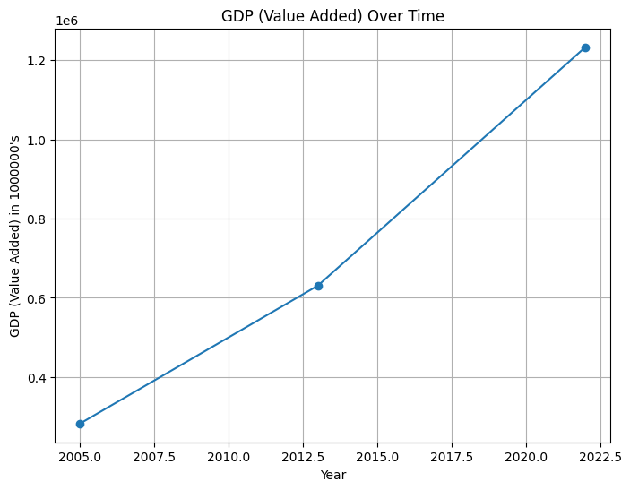

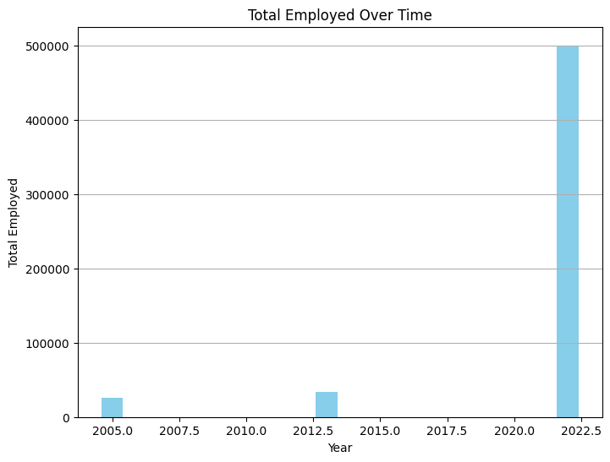

**Economic Growth and Employment Trends:**

GDP Growth: Over the years 2005, 2013, and 2022, the Gross Domestic Product (GDP) saw a significant increase, reaching 282.42 billion, 630.72 billion, and 1.23 trillion respectively. This indicates substantial economic growth over time.

**Employment:** The total number of employed individuals also surged from 25,497 in 2005 to 500,000 in 2022, suggesting a substantial increase in job opportunities and workforce engagement.

**Economic Indicators:**GDP per Capita: There's a clear rise in GDP per capita from $4,467 in 2005 to $100,000 in 2022, reflecting a notable improvement in the average income per person within the population.

**Output per Worker:** The productivity per worker has seen fluctuations, reaching $11,077 in 2005, peaking at $120,000 in 2022, and slightly dropping to $18,533 in 2013. This could indicate technological advancements or changes in the workforce's skill sets impacting productivity.

**Population and Demographics:**

**Working Age Population:** The number of individuals within the working age group increased significantly, from 31.4 million in 2005 to 100 million in 2022, portraying a substantial rise in the potential workforce.

**Share of Working-Age Population:** However, there's a discrepancy in the data for the share of the working-age population, which seems abnormally high in 2022 (150.15%). This might need clarification or correction as it seems unlikely.

**Total Population:** The total population saw an increase from 63.2 million in 2005 to 118 million in 2022, indicating overall population growth.

**Regional Labor Force Participation:**

**Regional Disparities:** There are significant differences in labor force participation rates across regions and age groups. For instance, regions like 'Amhara' and 'Somali' show higher participation rates compared to 'Harahi' or 'Addis Ababa'.

**Age Group Comparison:** Generally, the participation rates are higher in the 30-64 age group compared to the 15-29 age group across most regions.

**Conclusion:**

The data showcases a story of robust economic growth over the years, paralleled by an increase in employment opportunities and GDP. However, disparities exist in workforce participation rates among regions and age groups, indicating potential areas for targeted policy interventions or initiatives to balance participation rates and leverage the growing workforce effectively.

Additionally, anomalies like the abnormally high share of the working-age population in 2022 need further scrutiny to ensure data accuracy and reliability for informed decision-making.